BUSINESS INTELLIGENCE
EXPERIMENT 1: Data Acquisition and Data Profiling using BI Tools
STEP-WISE SOLUTION
PART A: DATA ACQUISITION
Step 1: Import the CSV Dataset
We opened Microsoft Power BI Desktop and selected Home → Get Data → Text/CSV. We selected the Sales_Data.csv file, checked the data preview, and clicked Load to import the dataset.
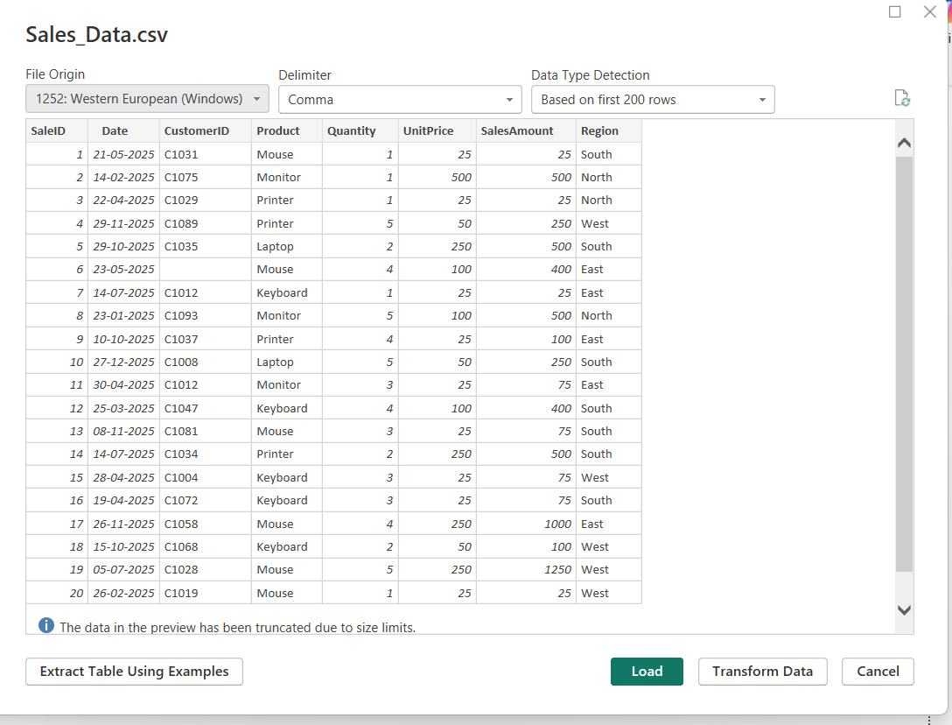
Step 2: Import the Excel Dataset
We selected Home → Get Data → Excel Workbook and opened the Employee_DB.xlsx file. From the Navigator window, we selected the required worksheet and clicked Load to import the employee data.
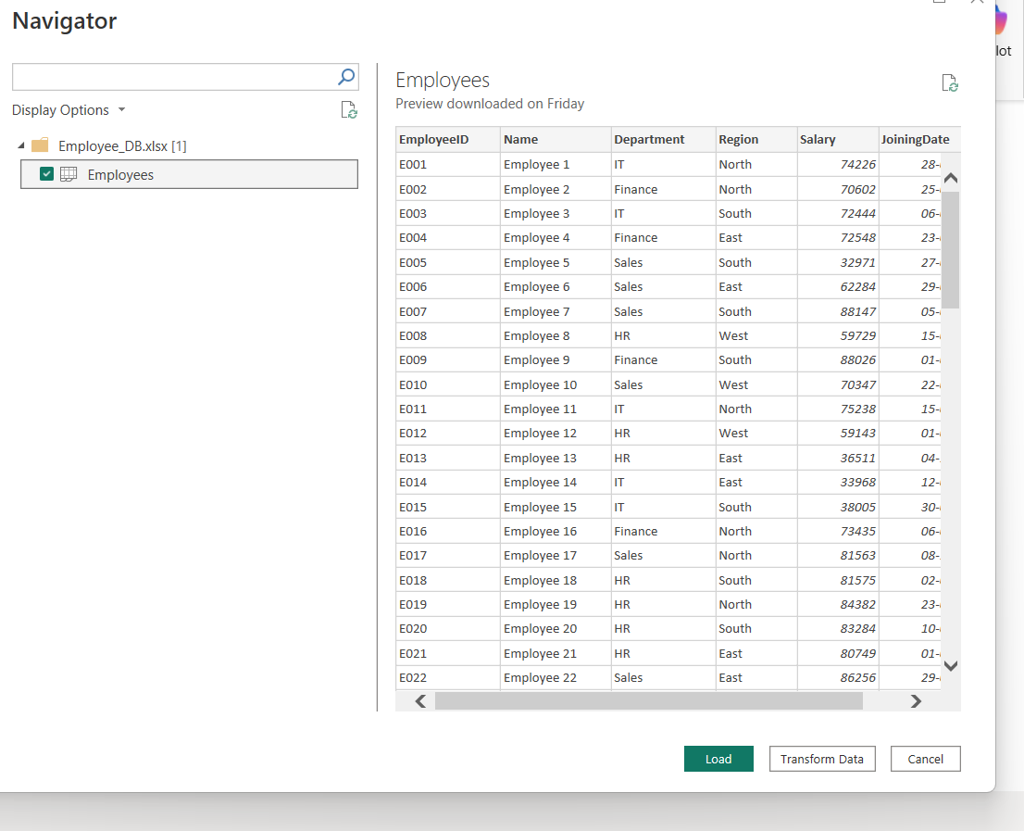

Step 3: Connect to the SQL Database
We selected Home → Get Data → SQL Server and entered the required server and database details. After connecting to the database, we selected the Transactions table and clicked Load.
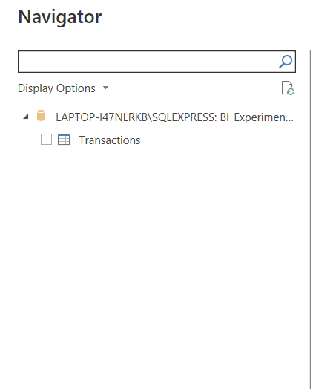
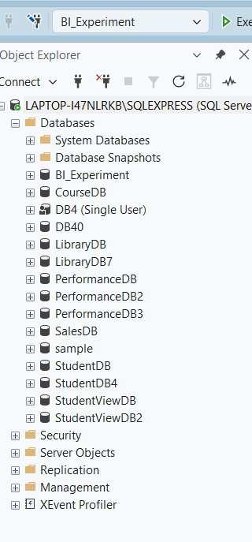
Step 4: Verify the Imported Datasets
We checked the Data pane in Power BI to verify that the CSV, Excel, and SQL datasets were successfully imported and available for further processing.
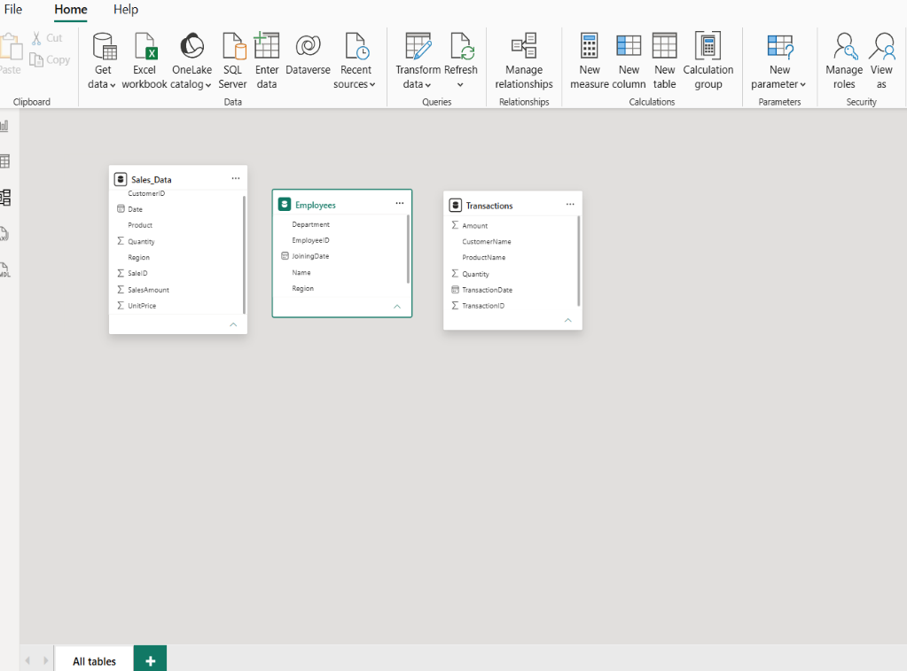

PART B: DATA PROFILING
Step 5: Open Power Query Editor
We selected Home → Transform Data to open the Power Query Editor. This editor was used to examine the structure and quality of the imported datasets.
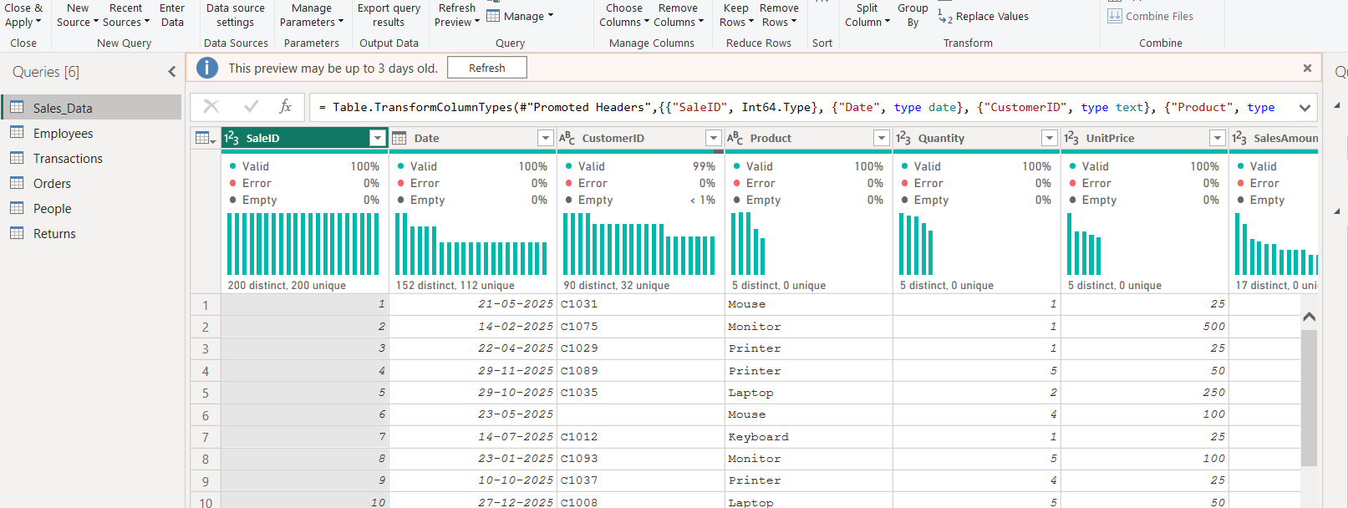
Step 6: Enable Column Quality
In Power Query Editor, we opened the View tab and enabled Column Quality. This allowed us to check the percentage of valid, empty, and error values present in each column.
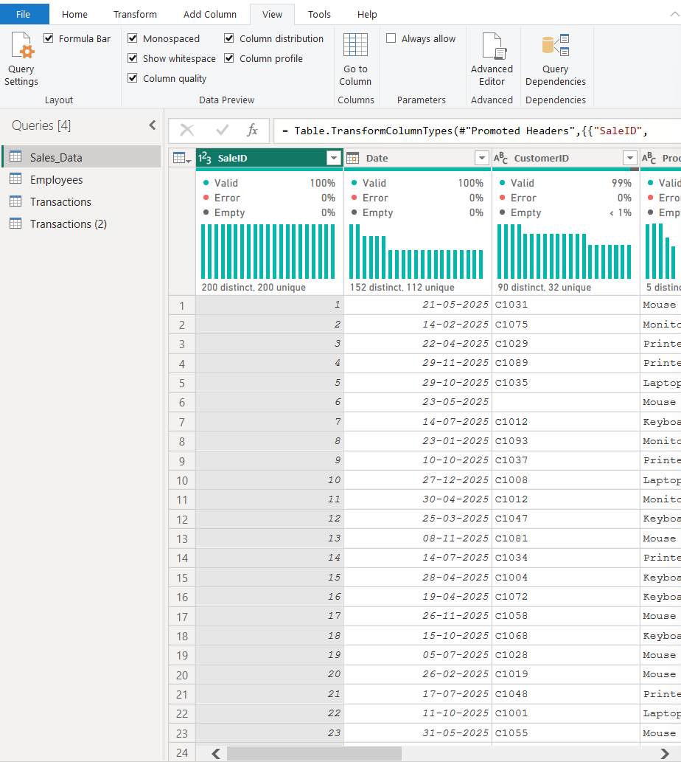
Step 7: Enable Column Distribution & Enable Column Profile
We enabled Column Distribution from the View tab. This helped us examine the distribution of values and identify the number of distinct and unique values in each column.
We enabled Column Profile from the View tab. We selected individual columns to view detailed statistics such as minimum, maximum, mean, median, and standard deviation where applicable.
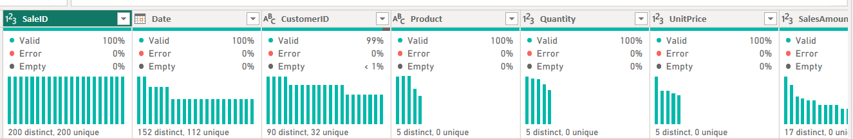

Step 9: Examine the Profiling Results
We selected the columns one by one and examined their data types, empty values, distinct values, unique values, and other available statistics. This helped us understand the structure and quality of the datasets.
PART C: DATA QUALITY ANALYSIS
Step 10: Identify Data Quality Issues
We examined the profiling results to identify possible data quality issues such as missing values, duplicate records, incorrect data types, errors, and unexpected values.

Step 11: Document the Data Quality Issues
We recorded at least three data quality issues found during profiling and provided a suitable remediation action for each issue.

Step 12: Complete the Data Profiling
After examining the required datasets and columns, the data acquisition and profiling process was completed. The identified data quality issues were documented for further correction before analysis. 